
ROUTING AND SWITCHING LAB
Project Report – Q1: RIP Configuration on a 4-Building Campus Network

NAME: SYEDA LEHZA BATOOL

ODOO ID: IU04-0322-0078

FACULTY: SIR SULTAN AHMED KHAN

SPRING SEMESTER = 8th

1. Objective
The objective of this project is to design and configure a 4-building campus network with redundant inter-building links, using the Routing Information Protocol (RIP) to enable dynamic routing between all networks. Each building consists of two floors, each hosting one PC, giving a total of 8 end devices. Connectivity between all PCs is verified using ping and traceroute, and routing tables are examined using the show ip route command on every router.

2. Network Diagram
The completed topology, built in Cisco Packet Tracer, is shown below. It consists of one core router, four building routers connected to the core and to each other (providing redundant paths for RIP), eight floor routers, eight switches, and eight PCs.
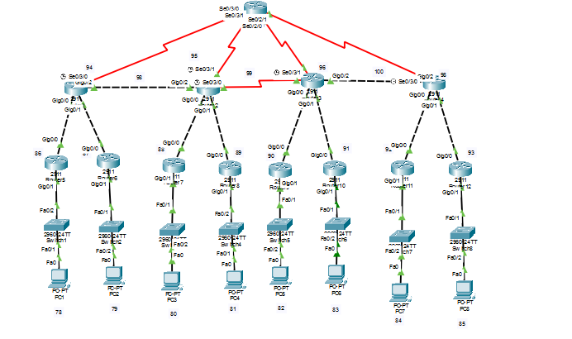

3. IP Addressing Scheme
Network addresses are derived from the last two digits of the student
Odoo ID (IU04-0322-0078 → 78),
Giving networks N1 = 192.168.78.0 through N23 = 192.168.100.0.

3.1 Floor LAN Networks (PC Subnets)
PC | IP Address | Subnet Mask | Default Gateway
PC1 | 192.168.78.2 | 255.255.255.0 | 192.168.78.1
PC2 | 192.168.79.2 | 255.255.255.0 | 192.168.79.1
PC3 | 192.168.80.2 | 255.255.255.0 | 192.168.80.1
PC4 | 192.168.81.2 | 255.255.255.0 | 192.168.81.1
PC5 | 192.168.82.2 | 255.255.255.0 | 192.168.82.1
PC6 | 192.168.83.2 | 255.255.255.0 | 192.168.83.1
PC7 | 192.168.84.2 | 255.255.255.0 | 192.168.84.1
PC8 | 192.168.85.2 | 255.255.255.0 | 192.168.85.1

3.2 Building Router – Floor Router Links
Floor Router | Port (→ Building) | IP | Port (→ Switch/LAN) | Gateway IP | Serves
Router5 | Gig0/0 | 192.168.86.2 | Gig0/1 | 192.168.78.1 | PC1
Router6 | Gig0/0 | 192.168.87.2 | Gig0/1 | 192.168.79.1 | PC2
Router7 | Gig0/0 | 192.168.88.2 | Gig0/1 | 192.168.80.1 | PC3
Router8 | Gig0/0 | 192.168.89.2 | Gig0/1 | 192.168.81.1 | PC4
Router9 | Gig0/0 | 192.168.90.2 | Gig0/1 | 192.168.82.1 | PC5
Router10 | Gig0/0 | 192.168.91.2 | Gig0/1 | 192.168.83.1 | PC6
Router11 | Gig0/0 | 192.168.92.2 | Gig0/1 | 192.168.84.1 | PC7
Router12 | Gig0/0 | 192.168.93.2 | Gig0/1 | 192.168.85.1 | PC8

3.3 WAN Links (Core–Building and Building–Building)
Link | Interfaces Used | Network
Core – Building1 | Serial0/3/0 (Core) / Serial0/3/0 (B1) | 192.168.94.0 /24
Core – Building2 | Serial0/2/1 (Core) / Serial0/3/0 (B2) | 192.168.95.0 /24
Core – Building3 | Serial0/2/0 (Core) / Serial0/3/0 (B3) | 192.168.96.0 /24
Core – Building4 | Serial0/3/1 (Core) / Serial0/3/0 (B4) | 192.168.97.0 /24
Building1 – Building2 | Gig0/2 (B1) / Gig0/2 (B2) | 192.168.98.0 /24
Building2 – Building3 | Serial0/3/1 (B2) / Serial0/3/1 (B3) | 192.168.99.0 /24
Building3 – Building4 | Gig0/2 (B3) / Gig0/2 (B4) | 192.168.100.0 /24

4. RIP Configuration
RIP version 2 was enabled on all 13 routers with auto-summarization disabled to preserve subnet boundaries. The table below lists the networks advertised by each router.
Router | Networks Advertised under RIP
Router0 (Core) | 192.168.94.0, 192.168.95.0, 192.168.96.0, 192.168.97.0
Building1 Router | 192.168.94.0, 192.168.98.0,192.168.86.0,192.168.87.0
Building2 Router | 192.168.95.0, 192.168.98.0, 192.168.99.0,192.168.88.0, 192.168.89.0
Building3 Router | 192.168.96.0, 192.168.99.0, 192.168.100.0, 192.168.90.0, 192.168.91.0
Building4 Router | 192.168.97.0, 192.168.100.0, 192.168.92.0, 192.168.93.0
Router5 | 192.168.86.0, 192.168.78.0
Router6 | 192.168.87.0, 192.168.79.0
Router7 | 192.168.88.0, 192.168.80.0
Router8 | 192.168.89.0, 192.168.81.0
Router9 | 192.168.90.0, 192.168.82.0
Router10 | 192.168.91.0, 192.168.83.0
Router11 | 192.168.92.0, 192.168.84.0
Router12 | 192.168.93.0, 192.168.85.0

5. Saved Router Configurations
Screenshots of the saved configuration (show running-config) for every router are provided below.

5.1 Router0 (Core)
[Router0 (Core) – show running-config — 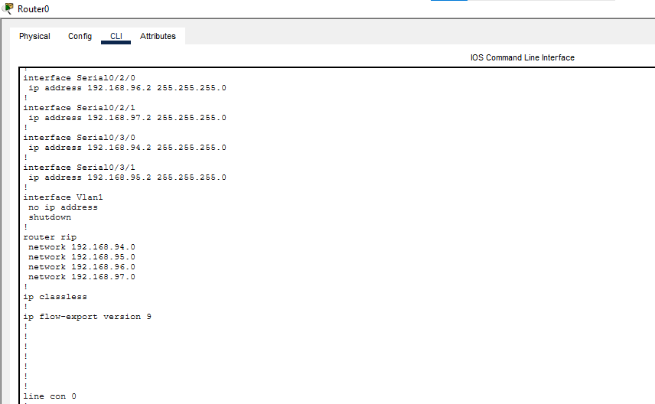

5.2 Building1 Router
[Building1 Router – show running-config — 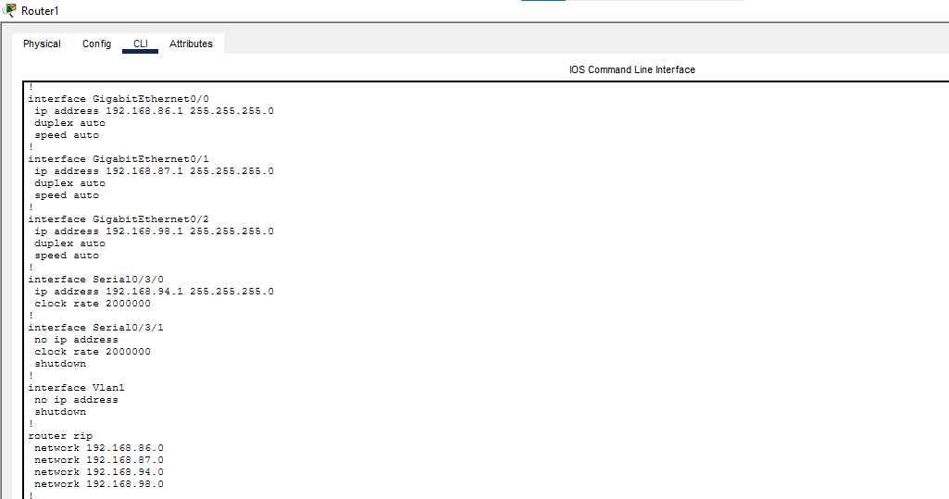]

5.3 Building2 Router
[Building2 Router – show running-config — 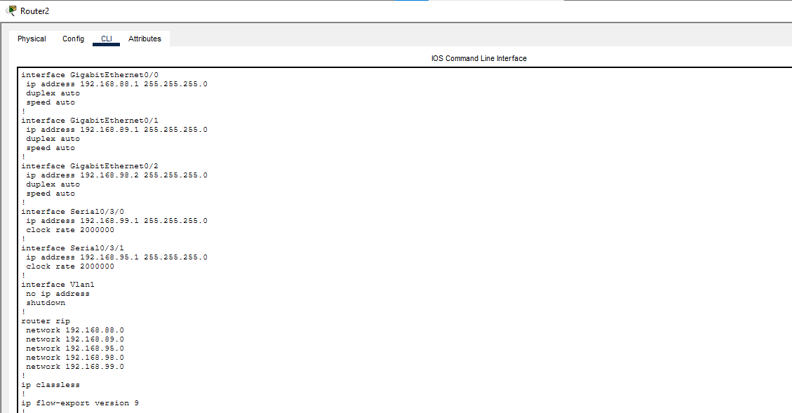]

5.4 Building3 Router
[Building3 Router – show running-config 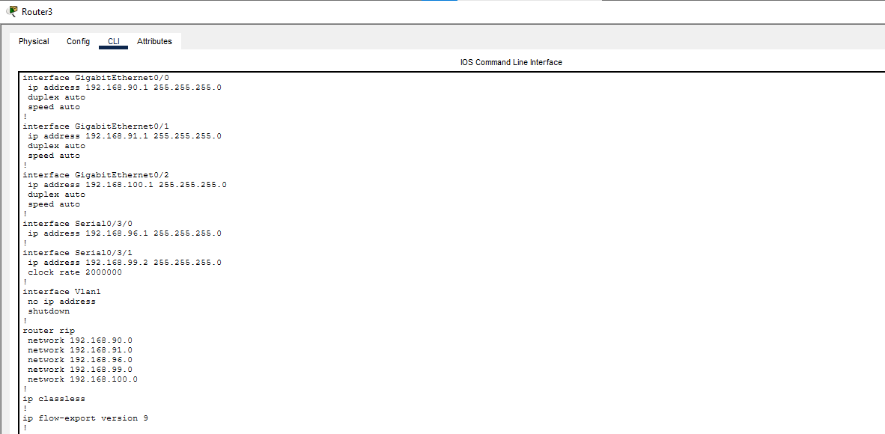]

5.5 Building4 Router
[Building4 Router – show running-config 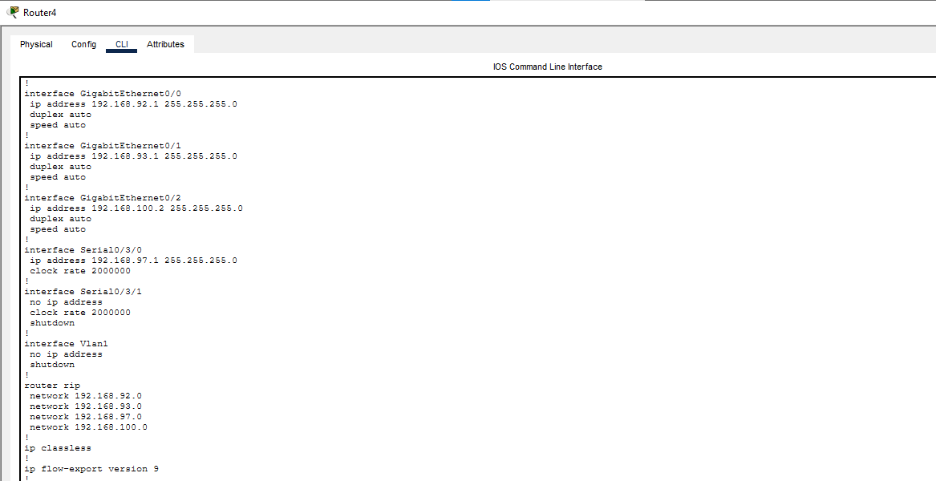]

5.6 Router5 (Floor)
[Router5 (Floor) – show running-config 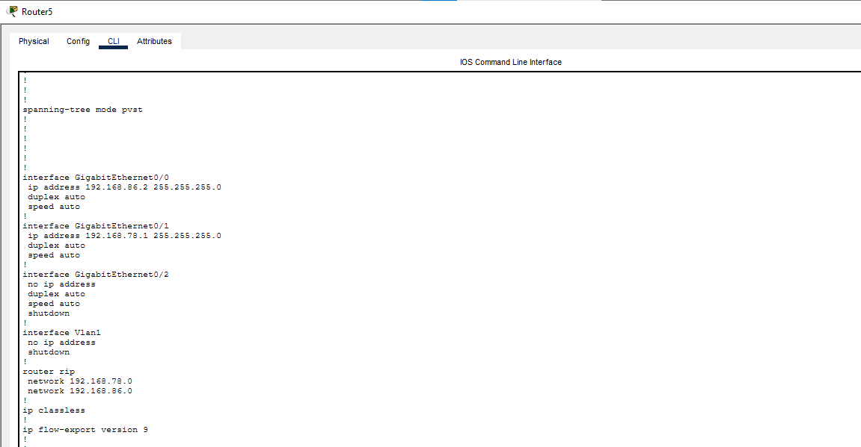]

5.7 Router6 (Floor)
[Router6 (Floor) – show running-config 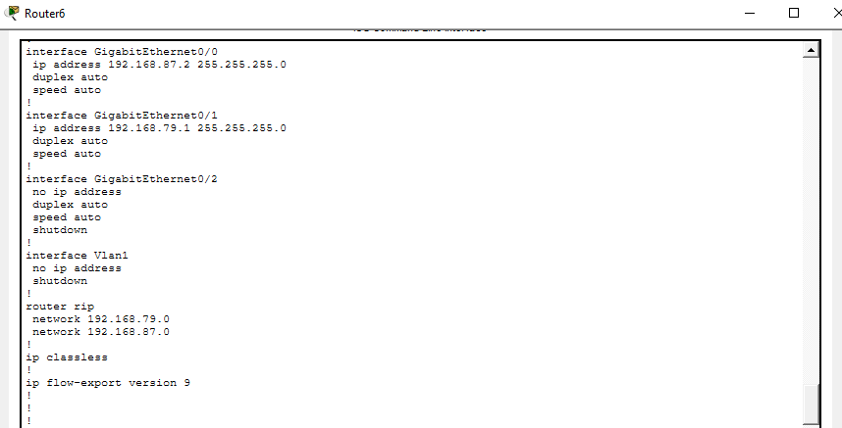]

5.8 Router7 (Floor)
[Router7 (Floor) – show running-config 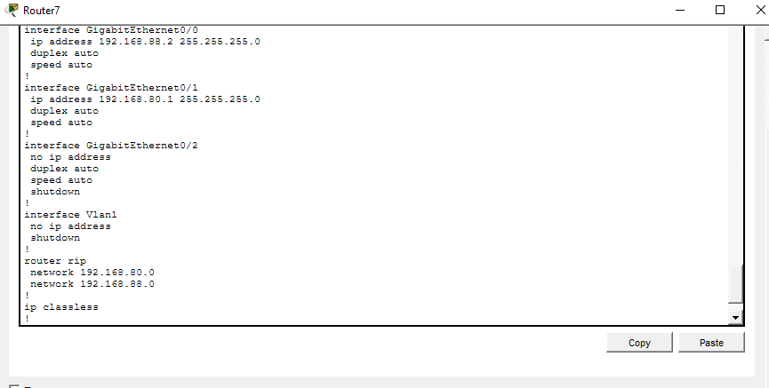]

5.9 Router8 (Floor)
[Router8 (Floor) – show running-config 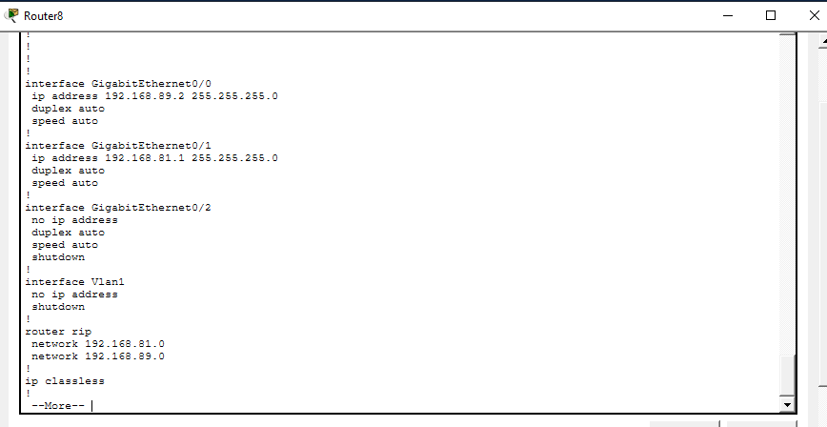]

5.10 Router9 (Floor)
[Router9 (Floor) – show running-config 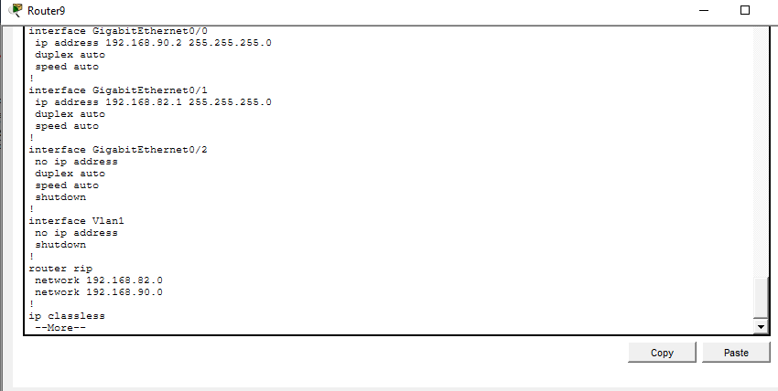]

5.11 Router10 (Floor)
[Router10 (Floor) – show running-config 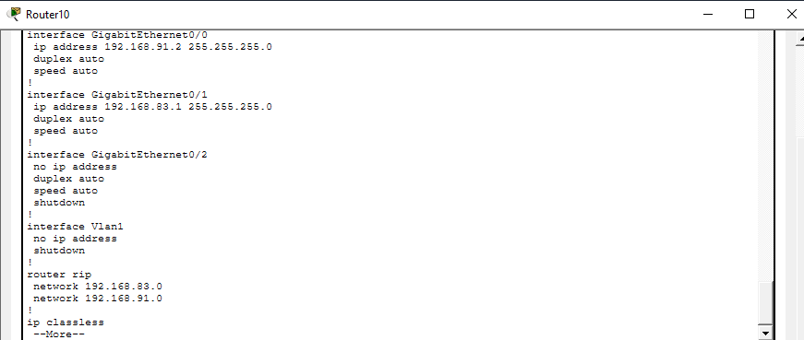]

5.12 Router11 (Floor)
[Router11 (Floor) – show running-config
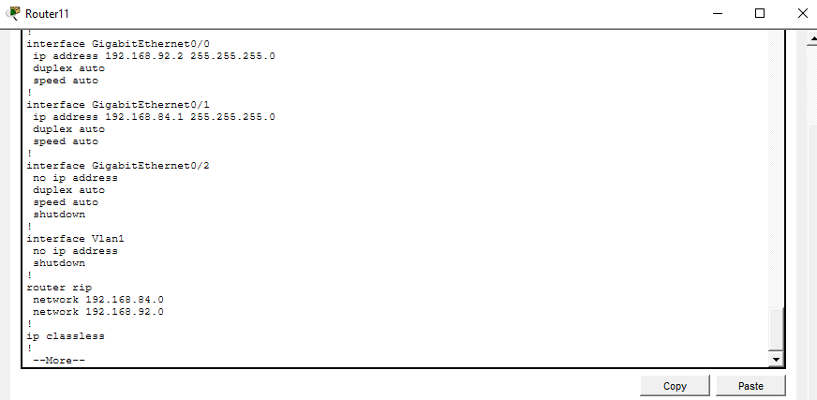]

5.13 Router12 (Floor)
[Router12 (Floor) – show running-config
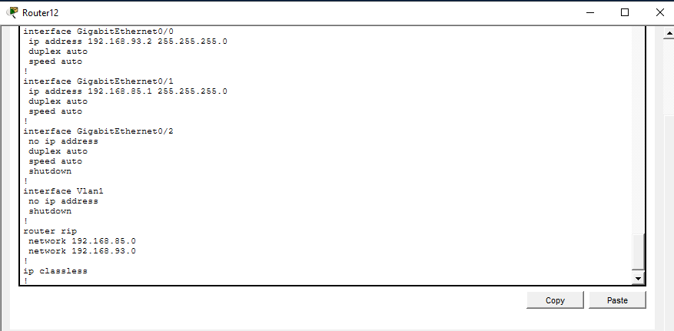]

6. Ping Connectivity Test (PC1 to all other PCs)
Ping was performed from PC1 to each of the remaining 7 PCs to verify end-to-end reachability across the RIP-routed network.

6.1 Ping PC1 → PC2
[Ping result: PC1 to PC2 — 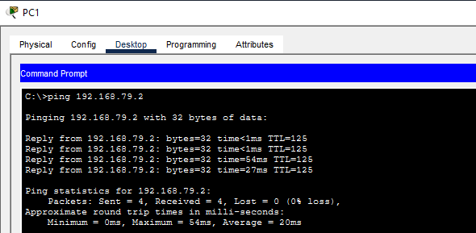]

6.2 Ping PC1 → PC3
[Ping result: PC1 to PC3 — 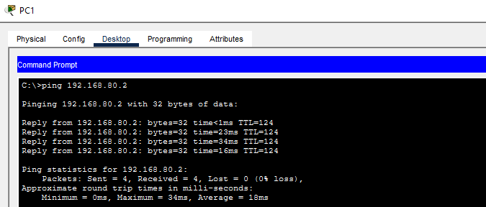]

6.3 Ping PC1 → PC4
[Ping result: PC1 to PC4 — 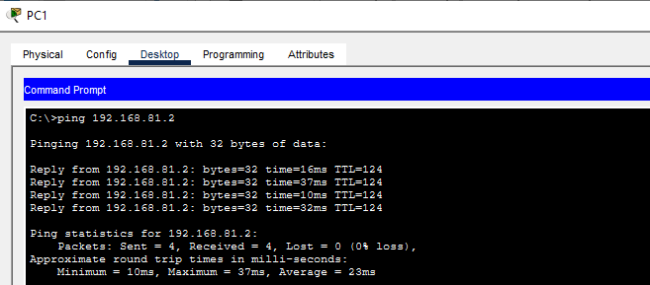]

6.4 Ping PC1 → PC5
[Ping result: PC1 to PC5 — 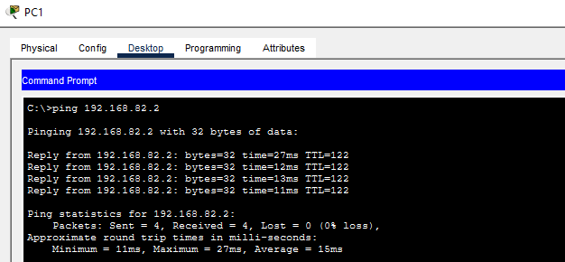]

6.5 Ping PC1 → PC6
[Ping result: PC1 to PC6 — 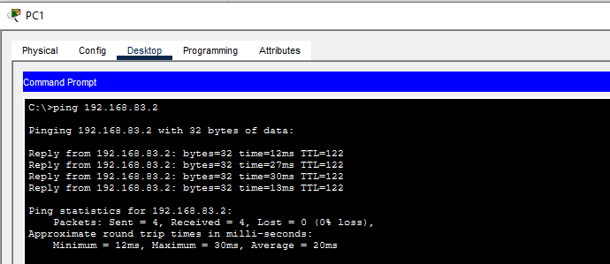]

6.6 Ping PC1 → PC7
[Ping result: PC1 to PC7 — 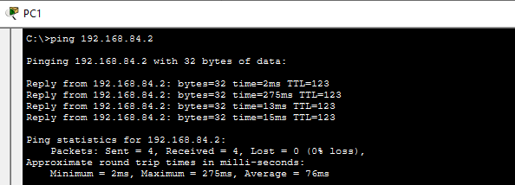]

6.7 Ping PC1 → PC8
[Ping result: PC1 to PC8 — 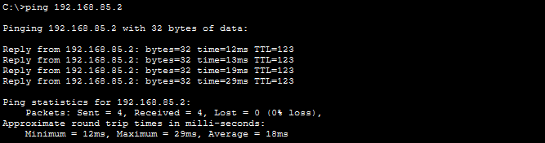]

7. Traceroute Test (PC1 to all other PCs)
Tracert was performed from PC1 to each of the remaining 7 PCs to show the hop-by-hop path taken through the routers.

7.1 Tracert PC1 → PC2
[Tracert result: PC1 to PC2 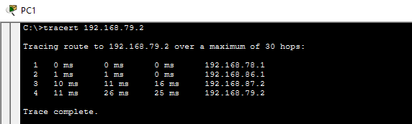]

7.2 Tracert PC1 → PC3
[Tracert result: PC1 to PC3 — 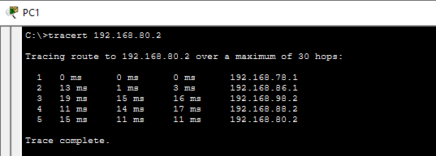]

7.3 Tracert PC1 → PC4
[Tracert result: PC1 to PC4 — 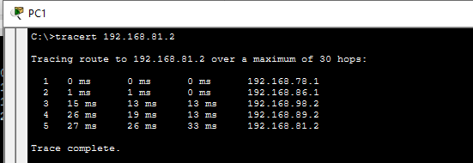]

7.4 Tracert PC1 → PC5
[Tracert result: PC1 to PC5 — 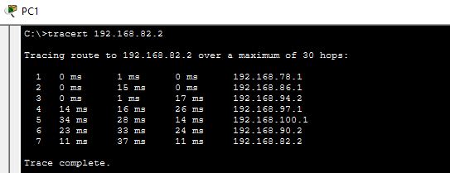]

7.5 Tracert PC1 → PC6
[Tracert result: PC1 to PC6 — 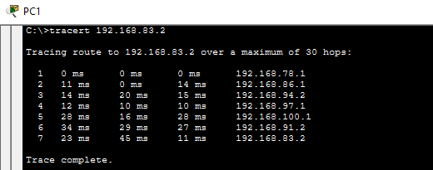]

7.6 Tracert PC1 → PC7
[Tracert result: PC1 to PC7
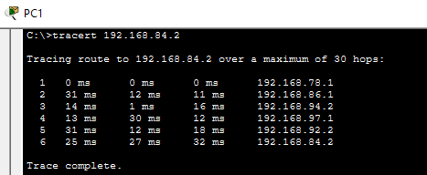 ]

7.7 Tracert PC1 → PC8
[Tracert result: PC1 to PC8 — 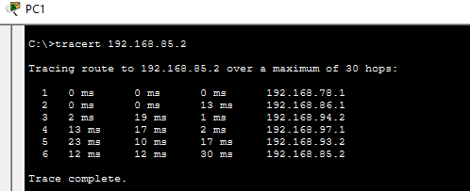]

8. Routing Table Verification (show ip route)
The output of "show ip route" was captured on every router to confirm that all 23 networks are learned/known (directly connected ‘C’ or via RIP ‘R’).

8.1 Router0 (Core) – show ip route
[Show ip route output – Router0 (Core) — 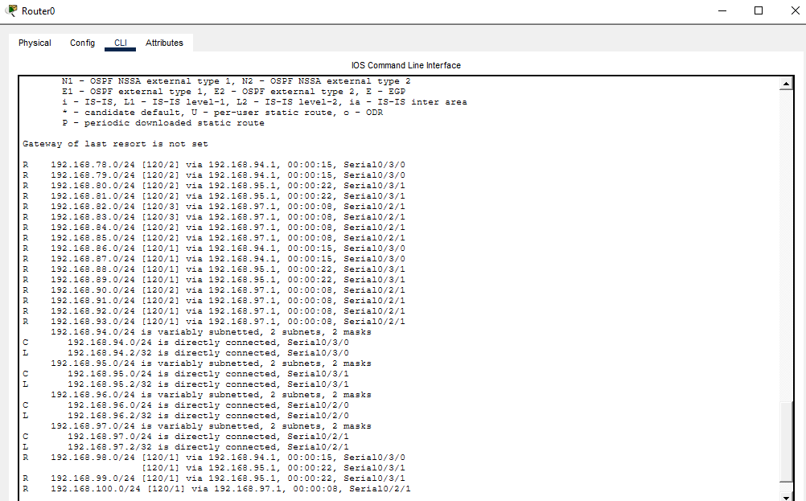]

8.2 Building1 Router – show ip route
[Show ip route output – Building1 Router — 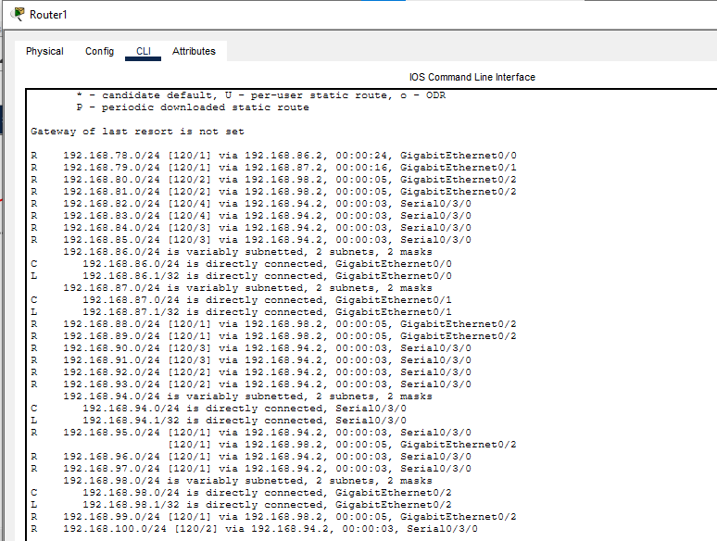]

8.3 Building2 Router – show ip route
[Show ip route output – Building2 Router —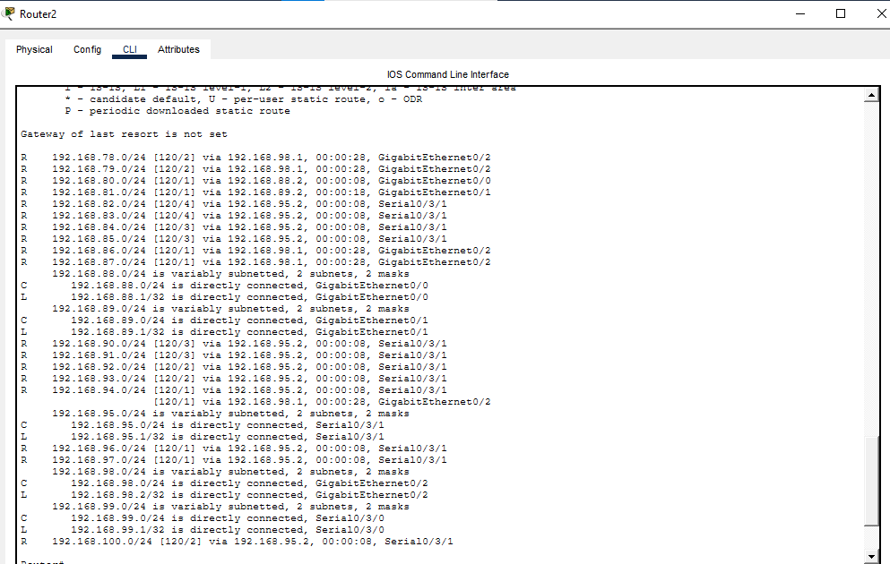]

8.4 Building3 Router – show ip route
[Show ip route output – Building3 Router 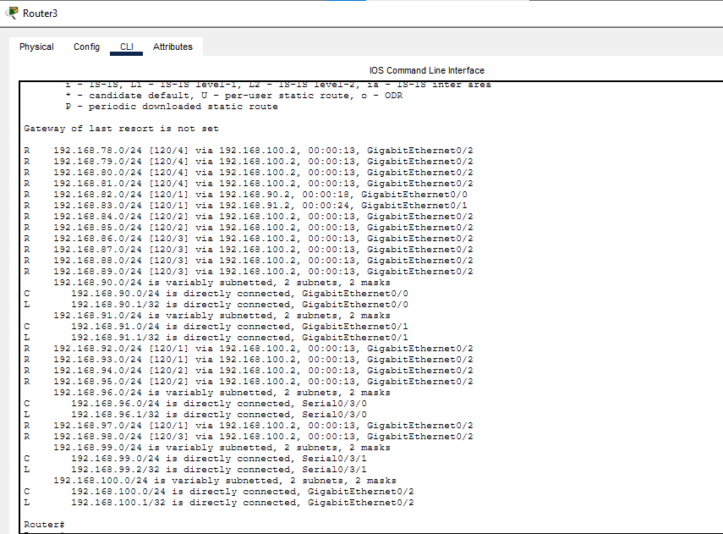]

8.5 Building4 Router – show ip route
[Show ip route output – Building4 Router 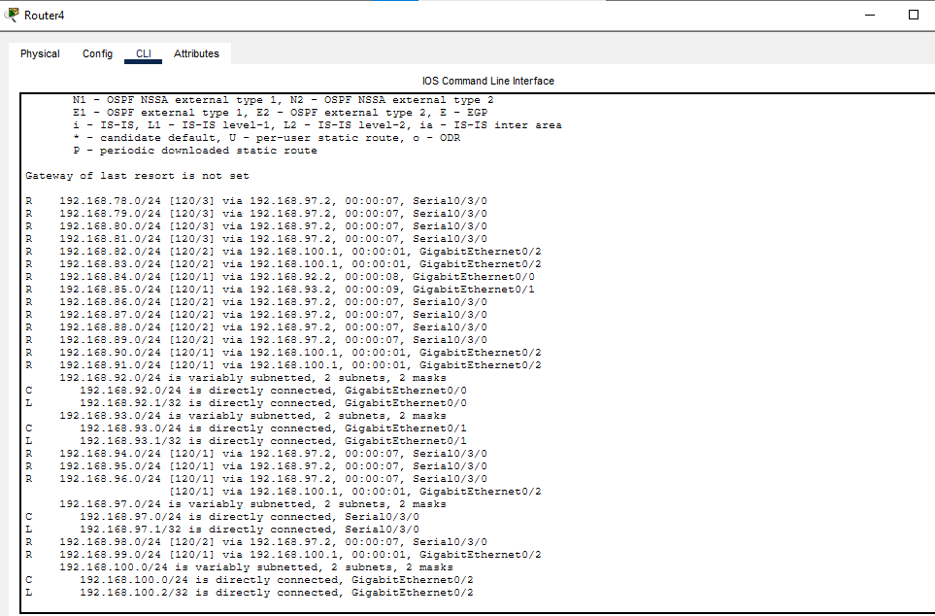]

8.6 Router5 (Floor) – show ip route
[Show ip route output – Router5 (Floor) 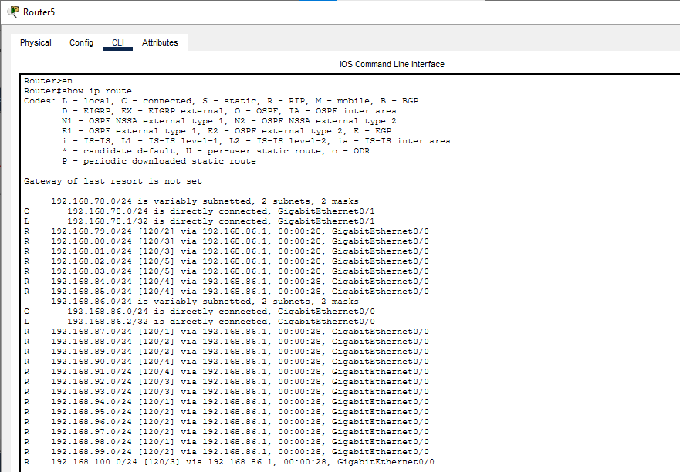]

8.7 Router6 (Floor) – show ip route
[Show ip route output – Router6 (Floor) 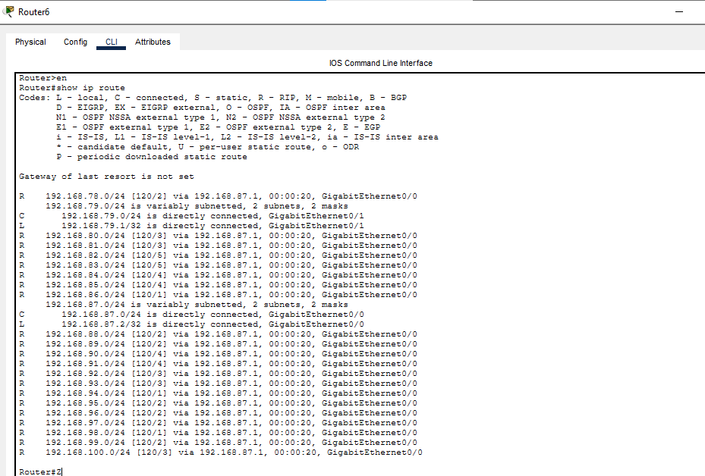]

8.8 Router7 (Floor) – show ip route
[Show ip route output – Router7 (Floor) — 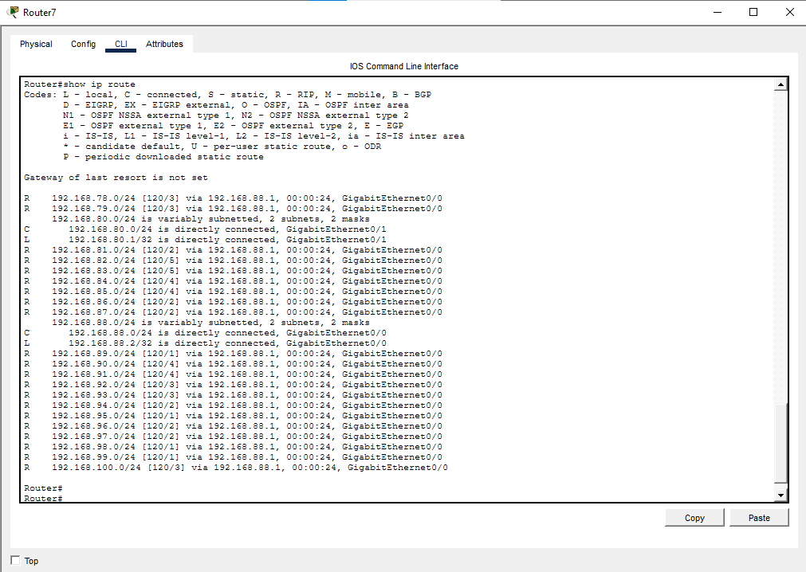]

8.9 Router8 (Floor) – show ip route
[Show ip route output – Router8 (Floor) — 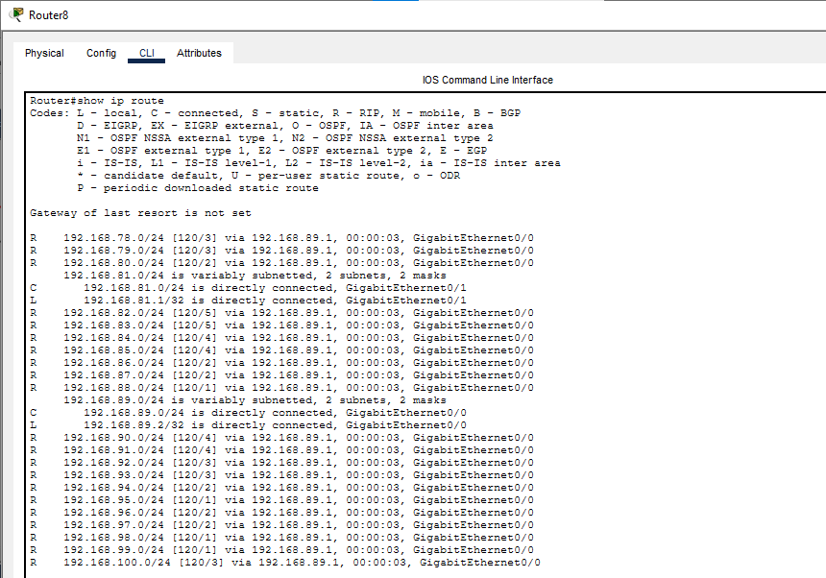]

8.10 Router9 (Floor) – show ip route
[Show ip route output – Router9 (Floor) — 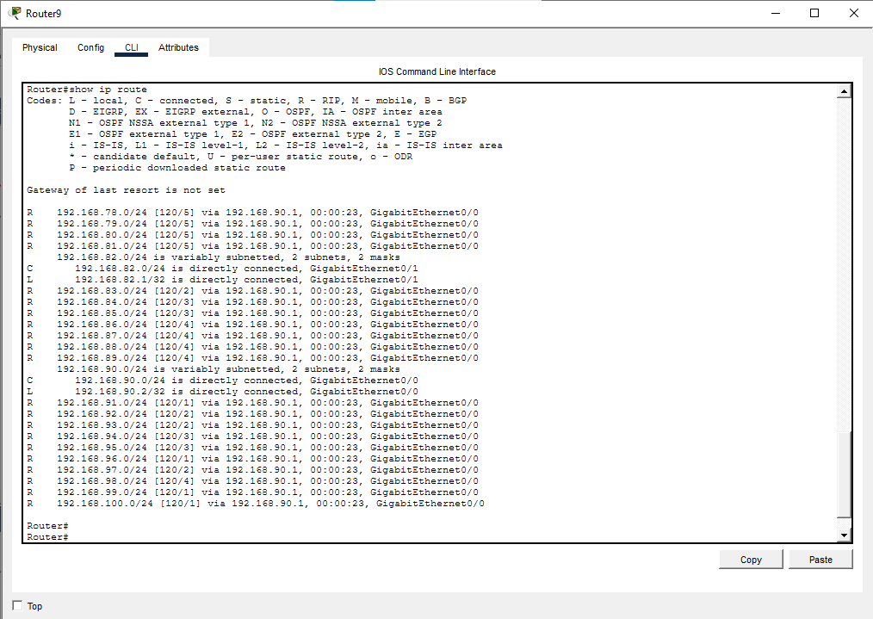]

8.11 Router10 (Floor) – show ip route
[Show ip route output – Router10 (Floor) — 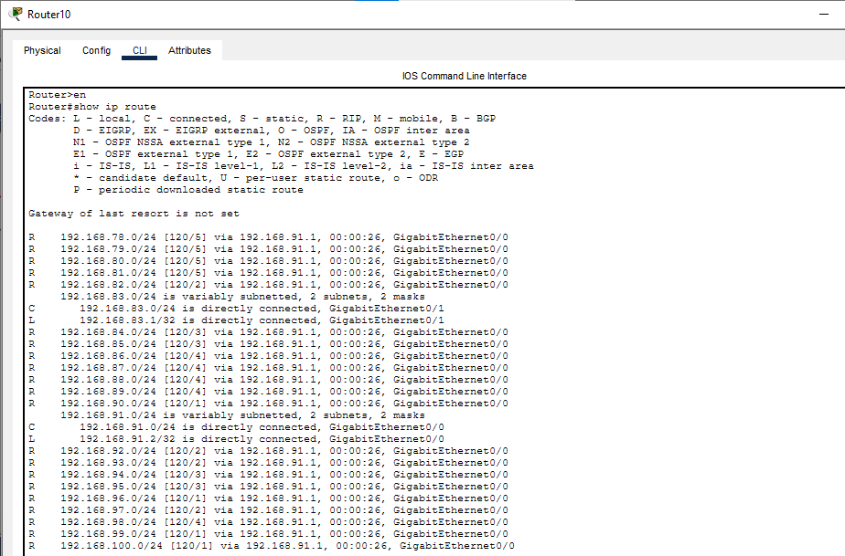]

8.12 Router11 (Floor) – show ip route
[Show ip route output – Router11 (Floor) 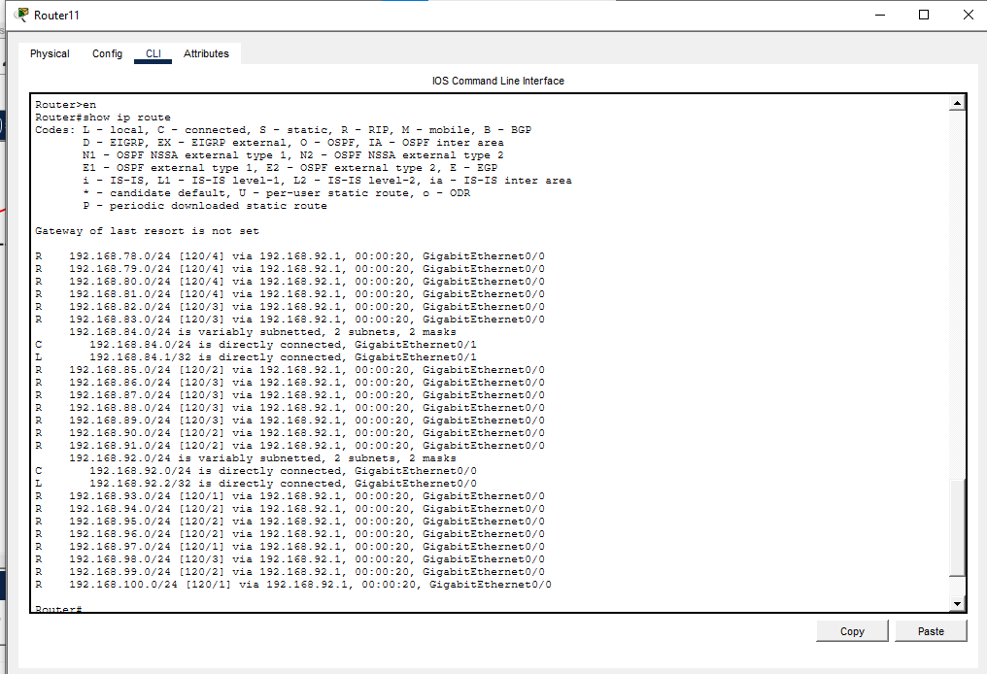]

8.13 Router12 (Floor) – show ip route
[Show ip route output – Router12 (Floor) —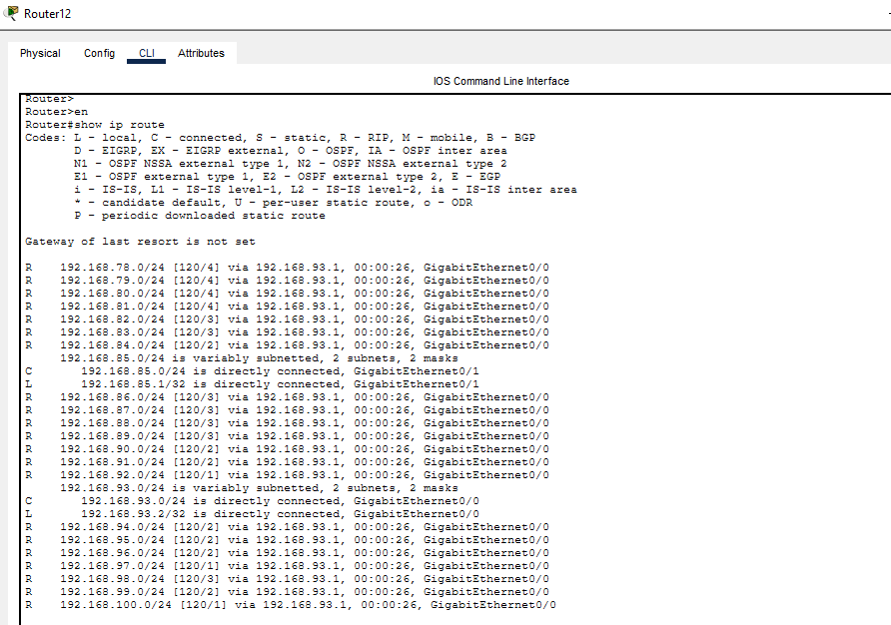]

9. Conclusion
The 4-building campus network was successfully designed and implemented in Cisco Packet Tracer with redundant links between the core and building routers, as well as direct building-to-building links. RIP version 2 was configured on all routers, enabling dynamic route discovery across all 23 subnets. Ping and traceroute tests from PC1 confirmed full connectivity to all other 7 PCs, and the show ip route output on each router verified that all networks were correctly learned via RIP or as directly connected routes.

